PROJECT DOCUMENTATION
Medical Diagnostic Center
ServiceNow Service Portal Application

Built on the ServiceNow Platform
Service Portal | Business Rules | GlideRecord | ACLs

Submitted by: K. Sai Dinesh
Institution: Nadimpalli Satyanarayana Raju Institute Of Technology
Date: 20-09-2026
Table of Contents
1. Introduction 1
1.1 Project Title 1
1.2 Team Members 1
1.3 Technology Used 1
2. Project Overview 1
2.1 Purpose 1
2.2 Key Features 1
2.3 Main User Workflow 1
3. Architecture 1
3.1 System Architecture 1
3.2 Database / Tables 1
4. Setup Instructions 1
4.1 Prerequisites 1
4.2 Application Setup 1
5. Application Structure 1
5.1 Service Portal Structure 1
5.2 Application Logic Structure 1
6. Running the Application 1
6.1 Steps 1
6.2 Portal Access 1
7. Application / API Documentation 1
7.1 Server-Side Operations 1
7.2 Example ServiceNow Server-Side Logic 1
8. Authentication and Authorization 1
8.1 Authentication 1
8.2 Authorization 1
8.3 Security Flow 1
9. User Interface 1
9.1 Major UI Screens 1
10. Testing 1
10.1 Testing Strategy 1
10.2 Functional Testing 1
10.3 UAT Result 1
11. Screenshots / Demo 1
11.1 Demo Workflow 1
11.2 Additional Screenshots 1
12. Known Issues 1
13. Future Enhancements 1
Conclusion 1

1. Introduction

1.1 Project Title
Medical Diagnostic Center – ServiceNow

1.2 Team Members
S.No. | Team Member | Role / Responsibility
1 | K.Sai Dinesh | Project Lead / ServiceNow Developer

1.3 Technology Used
The project is developed using the ServiceNow Platform and ServiceNow Service Portal. The application uses custom ServiceNow tables, Service Portal widgets, JavaScript, AngularJS, Business Rules, Client Scripts, GlideRecord, ServiceNow authentication, roles, ACLs, and email notifications.

2. Project Overview

2.1 Purpose
The purpose of the Medical Diagnostic Center project is to provide a centralized digital platform for patients to search for diagnostic tests, select a test, book an appointment, provide patient details, complete the payment process, track appointment status, and access laboratory reports.
The system reduces dependency on manual processes by providing an integrated workflow through the ServiceNow platform.

2.2 Key Features
- Diagnostic Test Catalog
- Test Selection
- Patient Details Management
- Online Appointment Booking
- Appointment Date and Time Selection
- Payment Status Management
- Booking Confirmation
- My Appointments
- Appointment Status Tracking
- Appointment Cancellation
- Automatic Laboratory Report Generation
- My Lab Reports
- Report Details and Findings
- Search, Sort and Filter
- Notifications
- Role-Based Access Control
- ServiceNow Business Rule Automation

2.3 Main User Workflow
Browse Tests → Select Test → Enter Patient Details → Book Appointment → Payment → Confirmation → Test Completed → Laboratory Report Generated → View Report

3. Architecture

3.1 System Architecture
The Medical Diagnostic Center follows a ServiceNow-based layered architecture.
Patient / Staff / Administrator
▼
ServiceNow Service Portal
▼
Service Portal Widgets / Client Scripts / AngularJS
▼
Business Rules / Server-Side JavaScript / GlideRecord
▼
ServiceNow Custom Tables
▼
Reports / Notifications / Application Records

Architecture Components
Layer | Technology / Component | Purpose
User Interface | ServiceNow Service Portal | Provides the user-facing application
Frontend | HTML, CSS, JavaScript, AngularJS | Creates interactive portal pages and widgets
Application Logic | Business Rules, Client Scripts | Implements application workflows and validations
Server Logic | JavaScript, GlideRecord, GlideSystem | Reads, creates and updates ServiceNow records
Database | ServiceNow Platform Database | Stores application data
Security | Roles, ACLs, Authentication | Controls access to application data
Notifications | ServiceNow Email Notifications | Sends booking/status/report notifications
Hosting | ServiceNow Cloud Platform | Hosts the application
Development Environment | ServiceNow PDI | Used for development and testing

3.2 Database / Tables
The application uses the following custom ServiceNow tables:
Table | Purpose
x_1894577_medica_0_patient | Stores patient information
x_1894577_medica_0_appointment_table | Stores appointment information
x_1894577_medica_0_diagnostic_test | Stores diagnostic test information
x_1894577_medica_0_report_table | Stores laboratory reports
sys_user | Stores ServiceNow user information

Table Relationships
- Patient records are associated with appointments.
- Appointments are associated with diagnostic tests.
- Completed appointments are associated with laboratory reports.
- Reports contain findings, report number, report date, status and verification information.
- ServiceNow users are used for authentication and user association.

4. Setup Instructions

4.1 Prerequisites
The following are required:
- ServiceNow account
- ServiceNow Personal Developer Instance (PDI)
- Supported web browser
- ServiceNow application development access
- Basic knowledge of ServiceNow configuration
- JavaScript knowledge for scripting and Business Rules

4.2 Application Setup
- Log in to the ServiceNow Personal Developer Instance.
- Open Application Studio / Studio.
- Create or open the Medical Diagnostic Center application.
- Create the required application tables.
- Configure table fields and reference relationships.
- Configure Service Portal pages.
- Create the required Service Portal widgets.
- Configure Client Scripts and Business Rules.
- Configure roles and ACLs.
- Configure email notifications.
- Insert sample diagnostic test records.
- Test the complete patient workflow.
- Verify laboratory report generation.
- Validate the application through UAT.

Note: The application runs entirely on the ServiceNow platform. No separate software installation, database setup, or external server configuration is required.

5. Application Structure
The application is developed on the ServiceNow platform. Its structure is organized into Service Portal components, which form the user interface, and application logic components, which implement the server-side behavior.

5.1 Service Portal Structure
Component | Purpose
Portal | Main Medical Diagnostic Center portal
Pages | Test Catalog, My Appointments, My Lab Reports and related pages
Widgets | Display tests, appointments, reports and interactive UI
Client Scripts | Handle client-side interaction and navigation
HTML | Widget/page structure
CSS | User interface styling
AngularJS | Dynamic portal behavior

5.2 Application Logic Structure
Component | Purpose
Business Rules | Server-side automation
GlideRecord | Database record operations
Client Scripts | Client-side validation and interaction
Email Notifications | Booking and status notifications
ACLs | Data access control
Roles | User authorization

Important Business Rule
An important automation is implemented on the Appointment table. When an appointment reaches the Completed status, the Business Rule automatically creates a corresponding laboratory report if a report does not already exist.

6. Running the Application
The Medical Diagnostic Center runs entirely on the ServiceNow platform and is accessed through the configured Service Portal. The steps below describe how to run and verify the complete workflow.

6.1 Steps
- Start the ServiceNow PDI.
- Log in to the ServiceNow instance.
- Open the configured Service Portal.
- Navigate to the Medical Diagnostic Center portal.
- Open the Test Catalog.
- Select a diagnostic test.
- Continue through the appointment booking process.
- Complete the payment step.
- Verify the appointment in My Appointments.
- Complete the appointment from the appropriate ServiceNow interface.
- Verify automatic report generation.
- Open My Lab Reports to view the generated report.

6.2 Portal Access
The project is accessed through the ServiceNow instance's configured Service Portal URL.

7. Application / API Documentation
Service Portal widgets communicate with their server-side widget scripts, which use ServiceNow APIs such as GlideRecord to retrieve and update records. The server-side operations supported by the application are listed below.

7.1 Server-Side Operations
Operation | Purpose
Retrieve Patient | Identifies the logged-in patient's record
Retrieve Appointments | Gets appointments associated with the patient
Retrieve Diagnostic Tests | Gets available tests
Create Appointment | Creates a new appointment record
Update Appointment | Updates appointment status/details
Cancel Appointment | Cancels an eligible appointment
Retrieve Reports | Gets laboratory reports
Generate Report | Business Rule creates report after completion

7.2 Example ServiceNow Server-Side Logic
var gr = new GlideRecord('x_1894577_medica_0_appointment_table');
gr.addQuery('created_by', gs.getUserID());
gr.query();

while (gr.next()) {
// Process appointment record
}

This uses GlideRecord to interact with ServiceNow database records.

8. Authentication and Authorization

8.1 Authentication
The application uses ServiceNow authentication to identify users accessing the Service Portal. The logged-in ServiceNow user can be identified using the current user session.

8.2 Authorization
Access is controlled using:
- ServiceNow Roles
- Access Control Lists (ACLs)
- Table-level access
- Record-level access
- User permissions
This ensures that users can access only the information and functionality permitted to their role.

8.3 Security Flow
User Login → ServiceNow Authentication → Role/ACL Validation → Authorized Portal/Data Access

9. User Interface
The Medical Diagnostic Center provides a ServiceNow Service Portal interface designed for patient interaction.

9.1 Major UI Screens

1. Home / Test Catalog
Displays available diagnostic tests and allows the patient to select a test.
Figure 1: Medical Diagnostic Center Home / Test Catalog
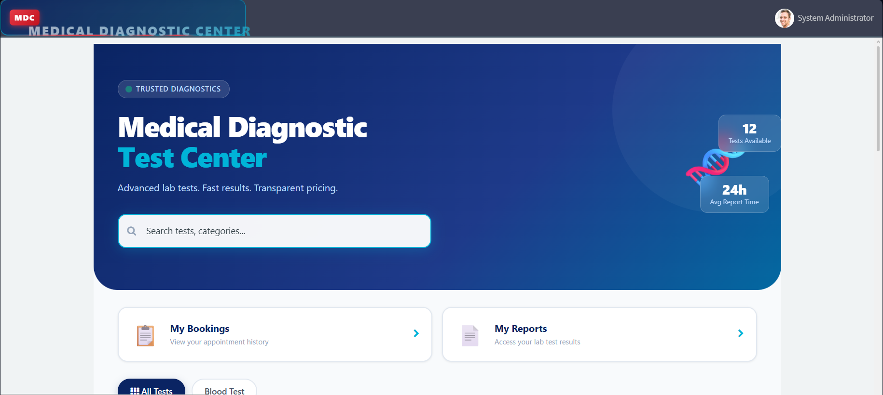

2. Diagnostic Test Selection
Allows the patient to review the details of a diagnostic test and select it for booking.
Figure 2: Diagnostic Test Selection
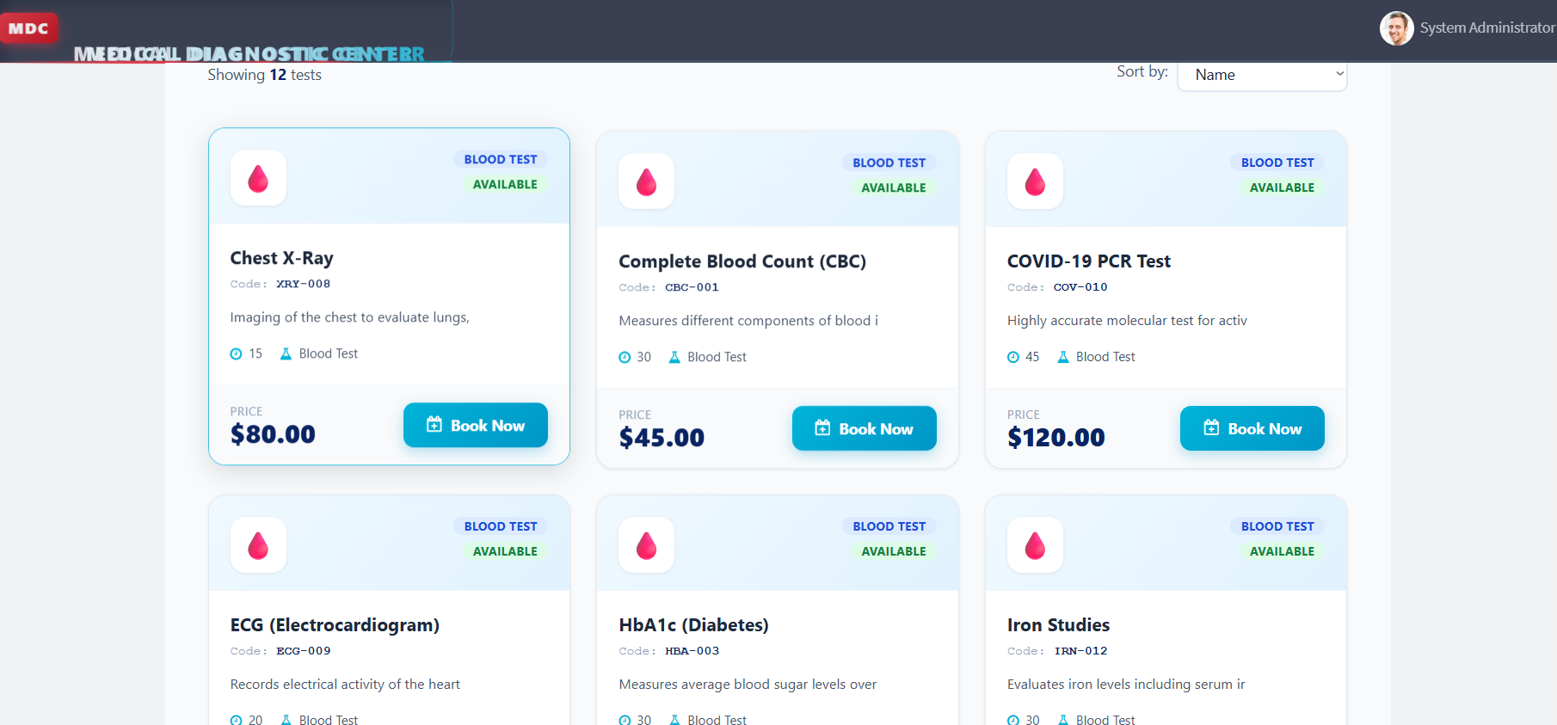

3. Appointment Booking
Allows the patient to enter details and select appointment information.
Figure 3: Appointment Booking

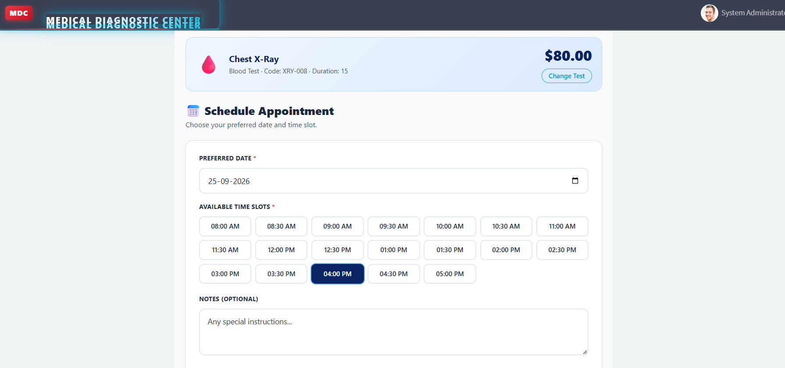

4. Payment
Displays the payment step and payment status.
Figure 4: Payment / Confirmation
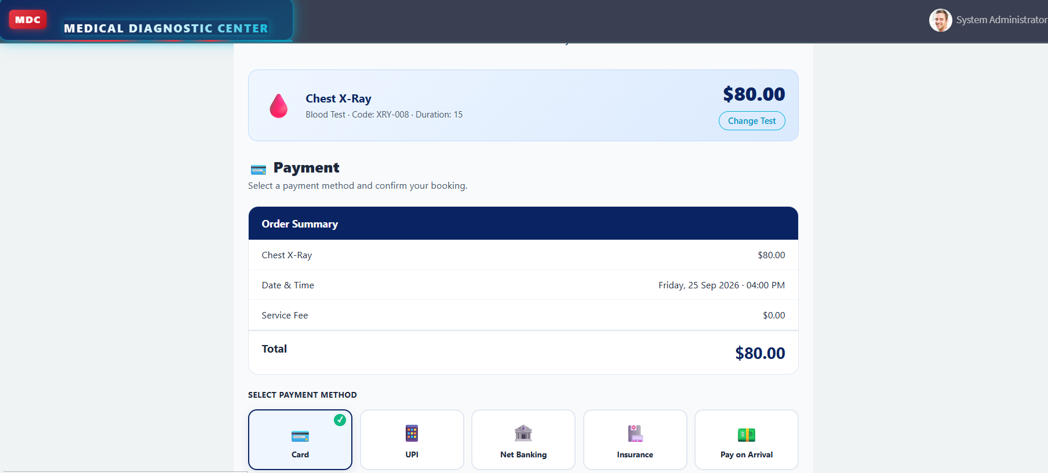

5. My Appointments
Displays the patient's appointments, status, search and sorting options.
Figure 5: My Appointments
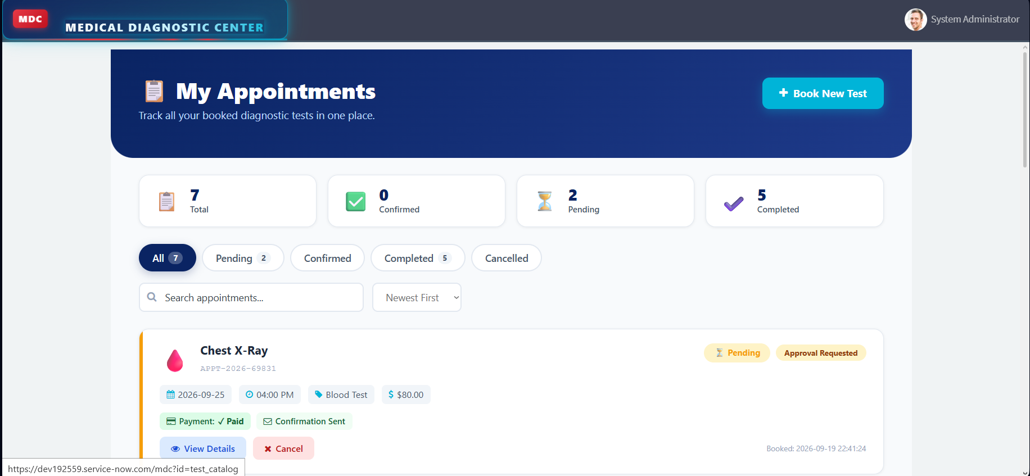

6. My Lab Reports
Displays available laboratory reports and report status.
Figure 6: My Lab Reports
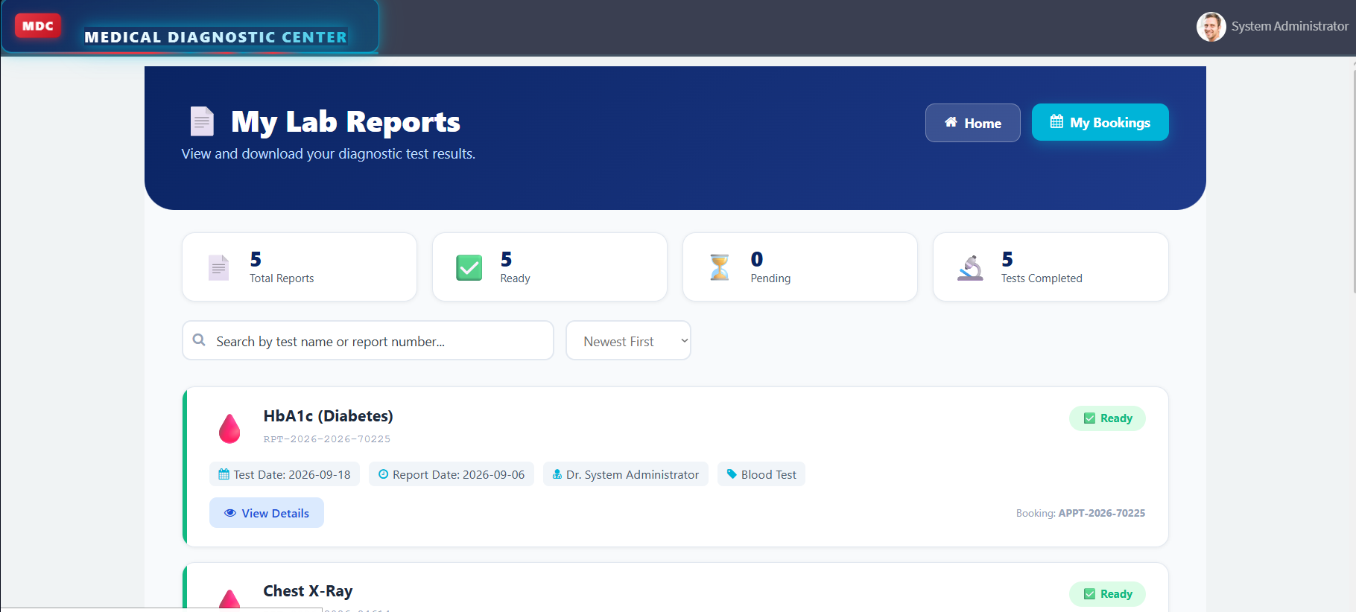

7. Report Details
Displays the following report information:
- Report Number
- Diagnostic Test
- Report Date
- Status
- Verified Doctor
- Findings
Figure 7: Report Details
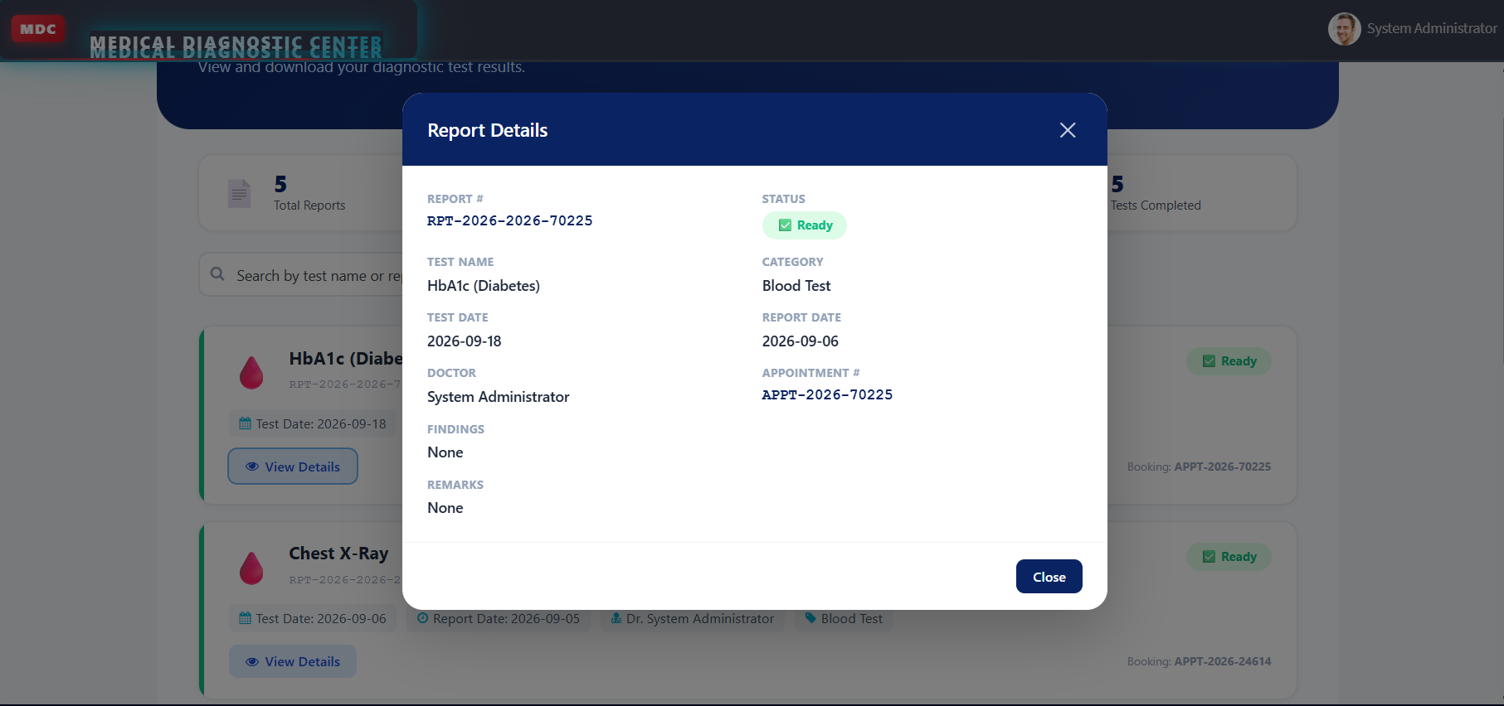

10. Testing

10.1 Testing Strategy
The application was tested using functional, system, integration and User Acceptance Testing (UAT).

10.2 Functional Testing
S.No. | Test Area | Result
1 | Test Catalog | PASS
2 | Test Selection | PASS
3 | Patient Details | PASS
4 | Appointment Booking | PASS
5 | Payment Status | PASS
6 | Appointment Tracking | PASS
7 | Appointment Cancellation | PASS
8 | Automatic Report Generation | PASS
9 | Laboratory Report Viewing | PASS
10 | Search and Sorting | PASS
11 | Notifications | PASS
12 | Security / Access Control | PASS

10.3 UAT Result
Metric | Result
Total Test Cases | 14
Passed | 14
Failed | 0
Not Tested | 0
Overall Result | PASS

11. Screenshots / Demo
This section contains the supporting screenshots for the application workflow, configuration and automation.

11.1 Demo Workflow
Login → Browse Tests → Select Test → Enter Details → Book Appointment → Payment → Confirmation → Complete Test → Generate Report → View Lab Report

11.2 Additional Screenshots
Figure 8: Patient Details
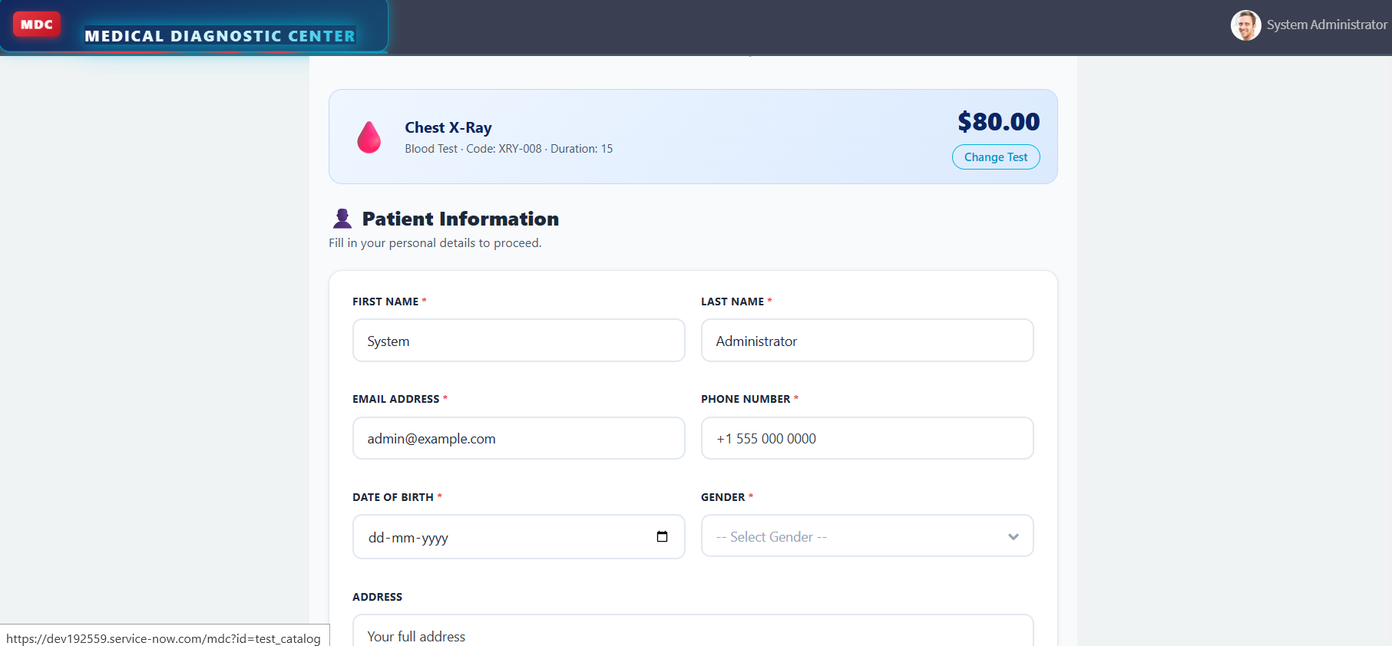

Figure 9: Payment Status
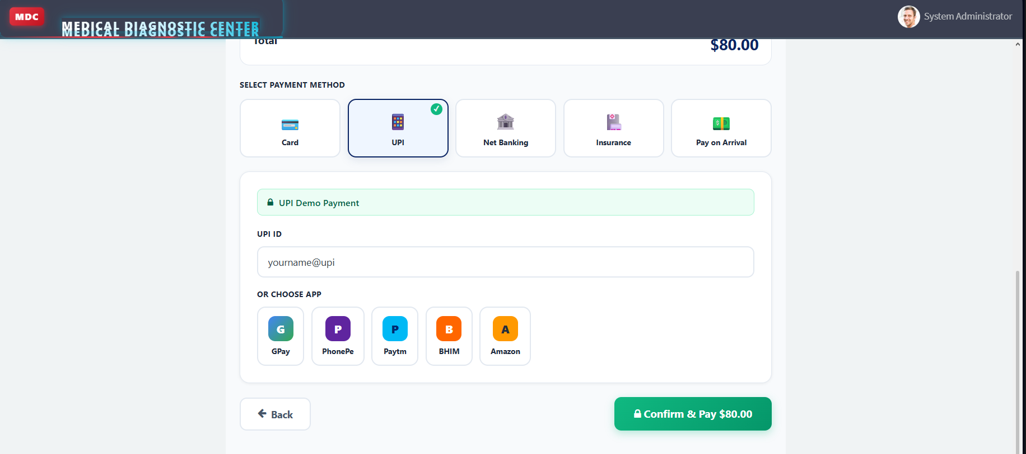

Figure 10: Booking Confirmation
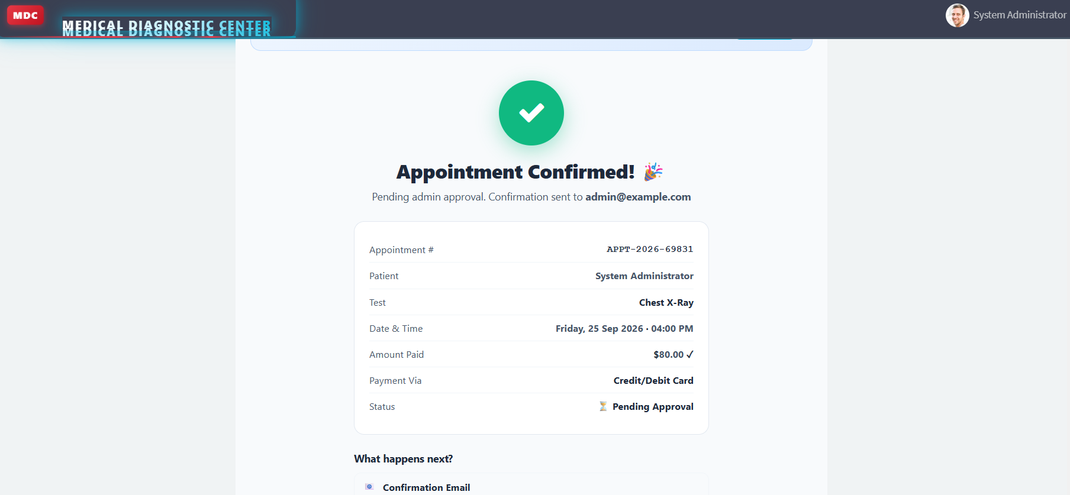

Figure 11: Appointment Cancellation
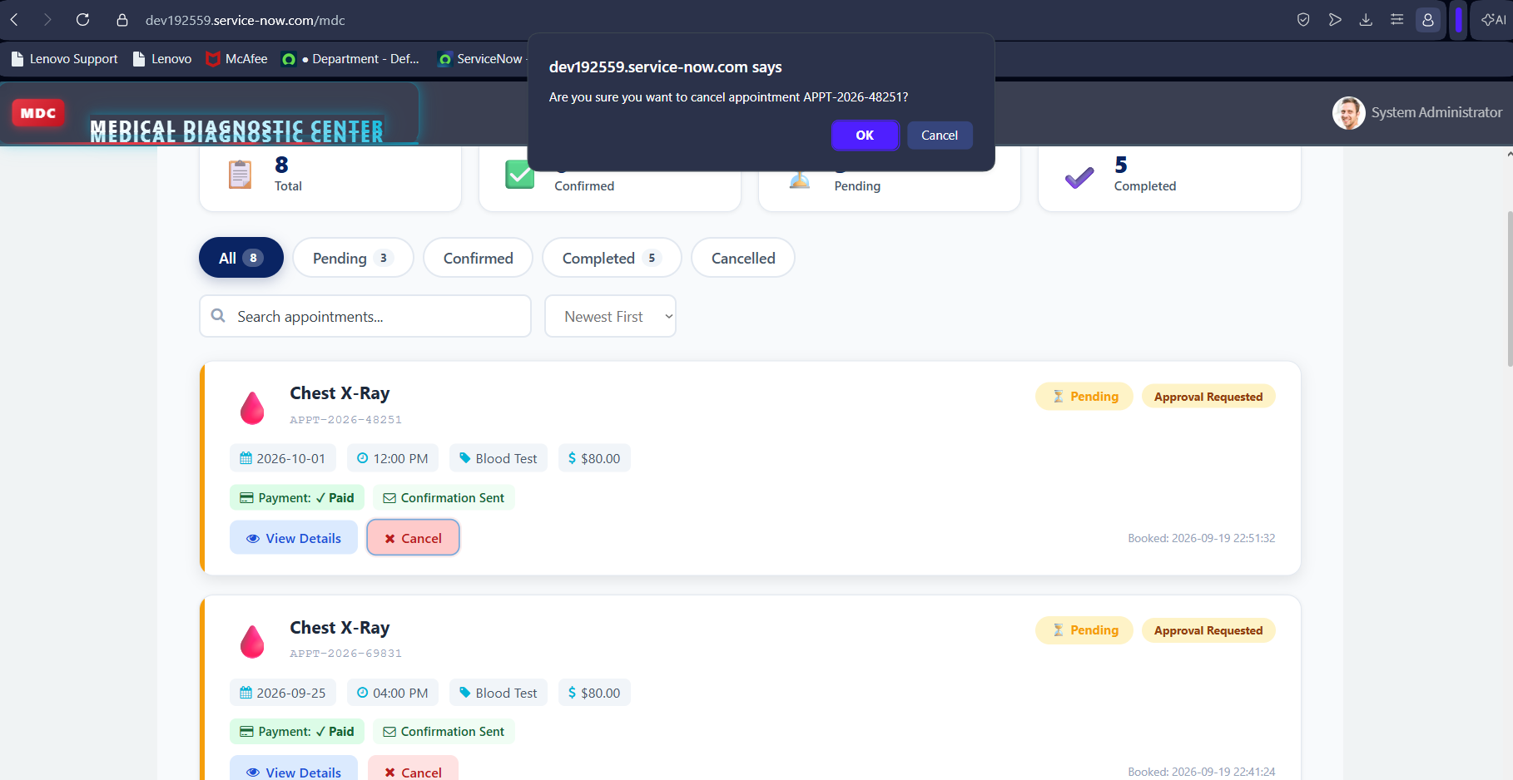
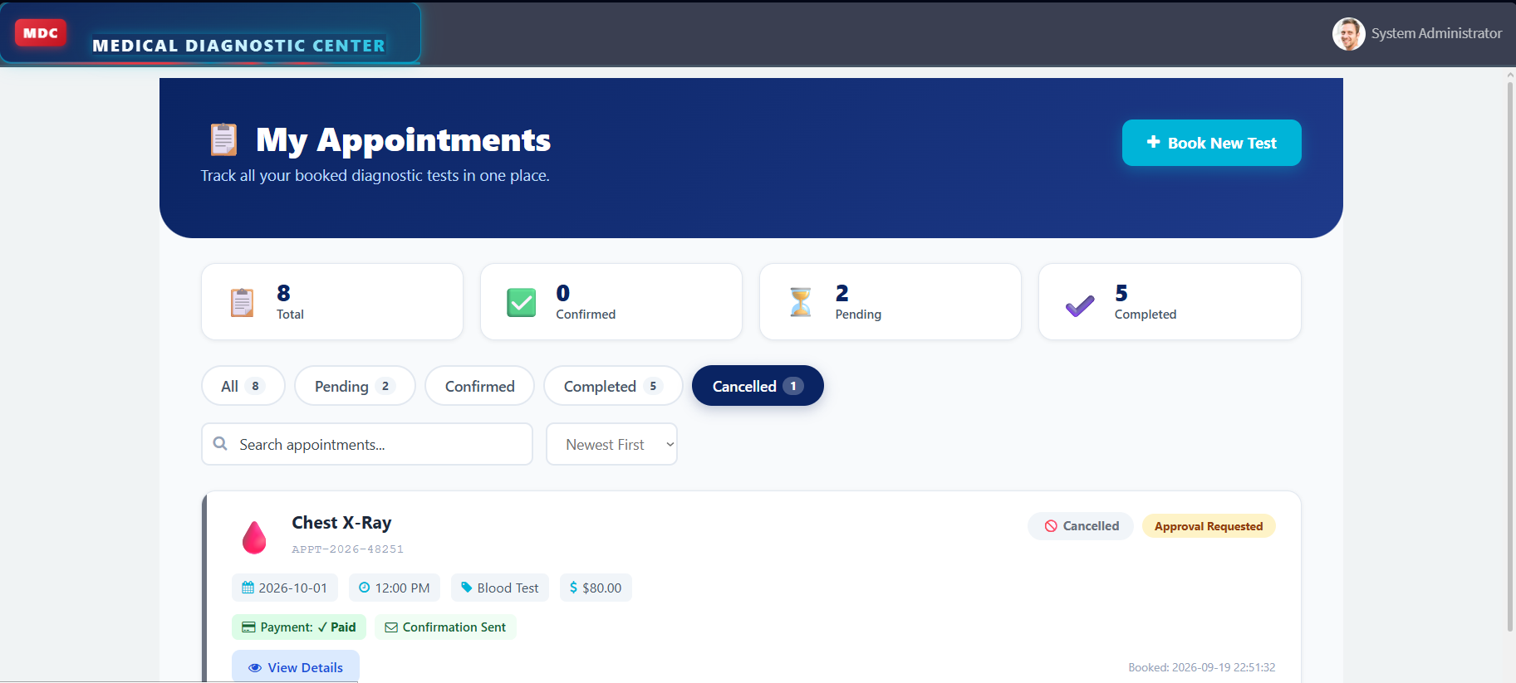

Figure 12: Business Rule – Automatic Report Generation
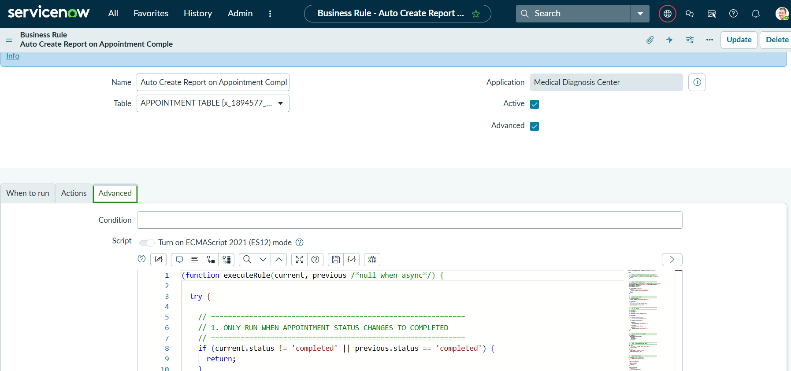

Figure 13: Notification / Email
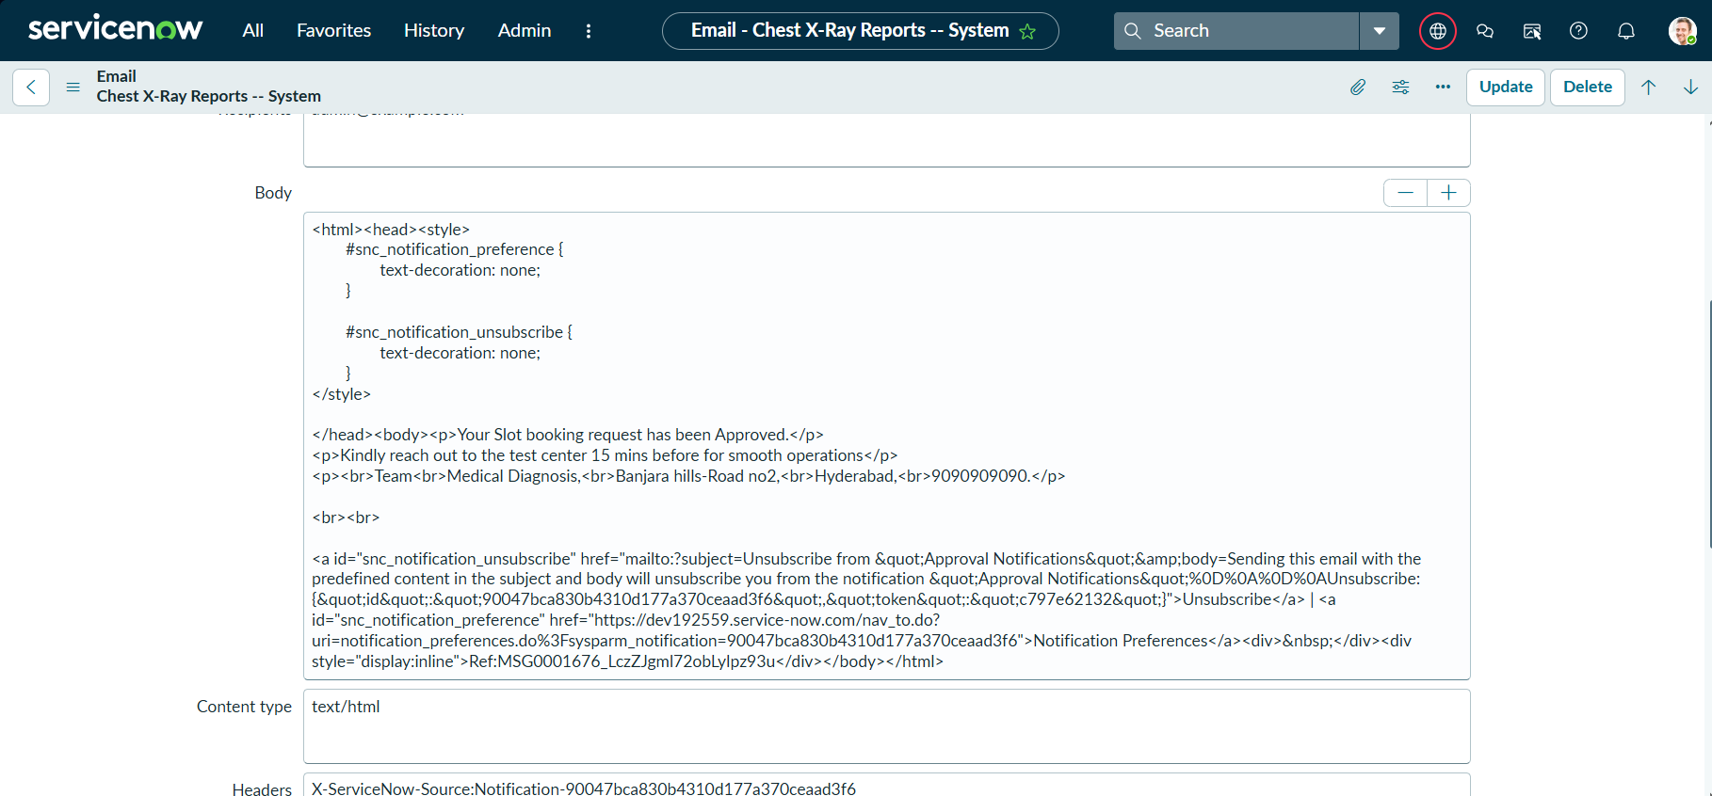

Figure 14: ACL / Role Configuration
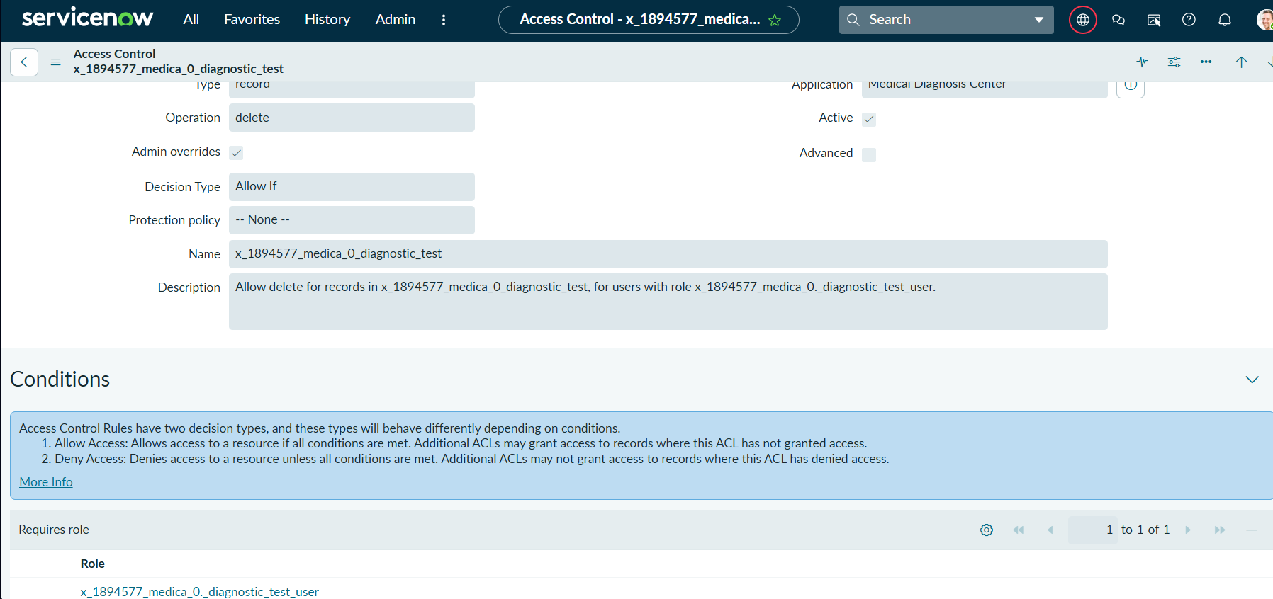

12. Known Issues
The following limitations are documented based on the current implementation:
S.No. | Known Issue / Limitation | Status
1 | The project does not integrate with an external payment gateway. | Current limitation
2 | The application does not use an external healthcare/laboratory API. | Current limitation
3 | Advanced analytics and predictive features are not implemented. | Future enhancement
4 | Laboratory report download functionality depends on availability of a report file/URL. | Current limitation
5 | The application is developed and tested within the ServiceNow PDI environment. | Current limitation

13. Future Enhancements
The following features can be added in future versions:

1. Real Payment Gateway Integration
Integrate a secure external payment gateway for real-time payment processing.

2. Advanced Analytics
Add dashboards for:
- Number of appointments
- Popular diagnostic tests
- Completed tests
- Report statistics
- Monthly booking trends

3. SMS Notifications
Add SMS notifications for appointment confirmation, reminders and report availability.

4. External Healthcare Integration
Integrate the application with external laboratory or healthcare systems through APIs.

5. Online Report Download
Provide downloadable PDF laboratory reports.

6. Doctor / Laboratory Staff Portal
Provide dedicated interfaces for doctors and laboratory technicians to update and verify test results.

7. Appointment Reminders
Automatically send reminders before the scheduled appointment.

8. Advanced Search
Allow patients to search reports and appointments using additional criteria.

Conclusion
The Medical Diagnostic Center – ServiceNow project provides a centralized digital solution for managing the diagnostic testing journey. The system integrates test browsing, appointment booking, payment status, appointment tracking, automated laboratory report generation, report viewing, notifications and access control within the ServiceNow platform.
The application was developed and tested using ServiceNow Service Portal, custom tables, Business Rules, Client Scripts, JavaScript, AngularJS and GlideRecord. The final UAT testing confirmed that the major application workflows functioned as expected.

